Introduction
This 25-page portfolio demonstrates my sustained academic and professional excellence in communication. It includes selected examples of published messaging that I authored, directed, advised on, edited, or oversaw — such as news releases, internal and external articles, web content, and multimedia messaging — primarily during my tenure as Director of Public Affairs and Communication for the USDA Forest Service Alaska Region.
With over 36 years of experience spanning from the 1990s to the present, I have worked across every facet of communication. My career has included roles as a news reporter and producer, public information officer, external affairs officer, public affairs specialist, assistant vice president of corporate relations, marketing manager, telemarketing supervisor, and director of communications in both public and private sectors.
From federal agencies to territorial governments, from newsrooms to crisis response coordination centers, I have consistently clarified, proposed, and integrated every communication message I have handled.
At the core of my philosophy is that communication should be audience-centered, context-aware, simplicity-focused, and engagement-driven. I believe that good messaging does not just inform — it engages, it invites, and it resonates. This belief drives the strategy behind every communication plan, news release, article, speech, video, social media post, briefing paper, or web content I have created. It is at the center of my thoughts whether that communication is verbal, non-verbal, written, visual, digital, interpersonal, or public — and it guides how I show up as a communicator, a leader, and a listener — with clarity, empathy, and purpose. My hands, head, and heart are present in every example within this portfolio, reflecting my professional capability and a sustained, intentional commitment to the principles of clear, effective, and authentic communication as both a practitioner and a learning scholar.
This portfolio highlights four major communication initiatives I led as Director of Public Affairs and Communications for the USDA Forest Service Alaska Region: the Alaska Roadless Rule, the Southeast Alaska Sustainability Strategy (SASS), the Alaska Cabins Project, and the Alaska Region Theme Initiative.
I selected these projects because they represent the full spectrum of modern public sector communication, ranging from high-profile national policy engagement to local community investment, from place-based recreation planning to strategic branding of public lands.
Each project required an advanced communication strategy, message development, stakeholder engagement, and cross-platform dissemination. Collectively, they demonstrate my ability to lead mission-critical messaging with clarity, credibility, and creativity while centering the public as a core audience.
These examples demonstrate my commitment to an audience-centered, straightforward, and engaging communication that inspires trust, motivates action, and fosters a shared purpose. Each presented its own complexities, stakeholders, and communication environments, reflecting the diversity of subject matter I led and the strategic breadth of my communication practice. This ensures that messages are written, widely published, distributed, and meaningfully received.
The Alaska Roadless Rule was a nationally watched, politically charged regulatory process that required careful framing, legal precision, and public trust-building. I developed and disseminated messaging that reached national media outlets, informed public meetings, and supported federal decision-making, ensuring our content was accurate and accessible to broad audiences.
The Southeast Alaska Sustainability Strategy required a shift from reactive communication to proactive storytelling. I translated investment data and complex environmental goals into relatable stories that honored Indigenous voices and regional values, resulting in increased coverage, partner amplification, and enhanced community engagement.
The Alaska Cabins Project created a unique opportunity to connect with the public on access, recreation, and equity. Through interactive Story Maps, comment campaigns, and earned media, I ensured the public had a voice and a visual connection to the project, helping generate positive momentum across Alaska and beyond.
Finally, the Alaska Region Theme initiative focused on long-term identity-building, utilizing visual storytelling, short films, and narrative design to convey who we are as an agency and a region. I guided every aspect of the campaign’s launch and amplification through social media, digital platforms, traditional media, and public venues, ensuring our message resonated across communities, cultures, partners, stakeholder groups, and the public.
While each project had its communication challenges, from navigating controversy to fostering enthusiasm, they also provided unique opportunities to apply strategic communication theory in real-world settings, always with the goal of clarity, connection, and credibility.

Alaska Roadless Rule (2018–2020)

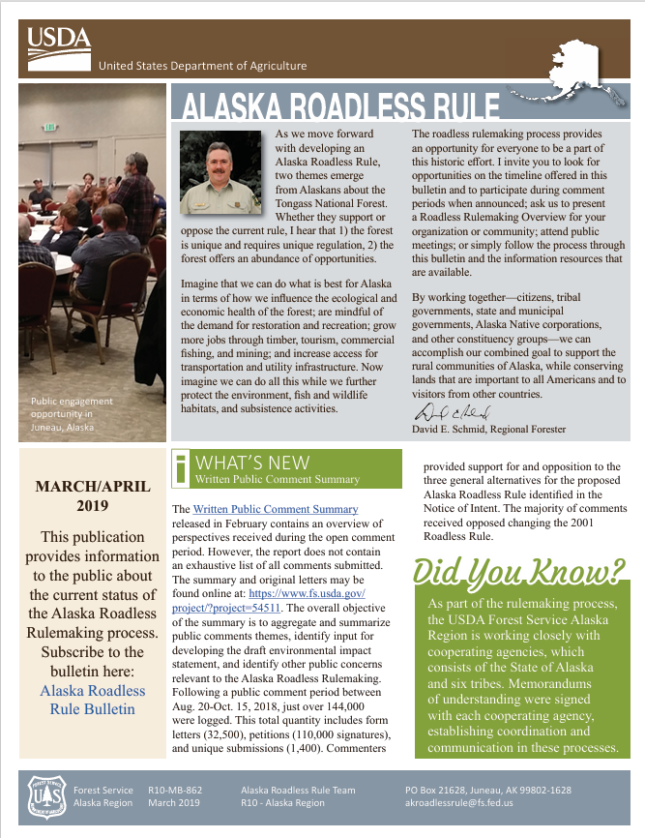
Overview:
The Alaska Roadless Rule was a significant policy initiative to determine the appropriate management of roadless areas within the Tongass National Forest in Alaska. Initiated in response to a petition from the State of Alaska, the rulemaking process sought to develop a state-specific approach to roadless area management, considering both conservation and economic development needs. The Alaska Roadless Rule was one of the most politically charged and publicly scrutinized efforts of my career—it was also the first project I was assigned to when I joined the Forest Service in November 2018.
On day one of my first week, I was immediately thrown into complex, high-stakes meetings filled with acronyms I had never heard, policy debates I had not yet studied, and urgent and overwhelming challenges.
While I knew I had a steep learning curve ahead—about the agency, the Tongass National Forest, and the intricacies of roadless rulemaking—I entered the project with deep experience in communication strategy.
I quickly immersed myself in the work and became the trusted messaging advisor to national and regional leaders. I developed and distributed communication products that were timely, clear, and crafted to navigate legal, cultural, and political sensitivities. Through earned media, public meetings, and stakeholder engagement, I ensured that broad audiences saw, heard, and understood the Forest Service’s messages.
The communication plan was simple– share timely, accurate, engaging, interactive, empowering, and transparent information to all levels of stakeholders using applicable communication products and platforms for the identified audiences. Below is a timeline with links to published media products and media coverage.
In August 2018, the State of Alaska submitted a petition for rulemaking to Secretary of Agriculture Sonny Perdue. The Secretary and Alaska Governor Bill Walker agreed to undertake the state-specific roadless rule to address roadless management cooperatively.
Communication:
- State of Alaska, USDA Forest Service begin official work on Alaska Roadless Rule (Aug. 2, 2018, Juneau)
Media Coverage:
  - Earth Justice (Aug. 2, 2018, Washington D.C.): USDA Announces effort to strip National Forest protections in Alaska
  - Alaska Public Media (Aug. 2, 2018, Alaska): New roads in the Tongass? Forest Service signs off on state’s ask
  - Alaska Public Media (Aug. 3, 2018, Alaska): Southeast Alaska residents react to Roadless Rule announcement
  - Daily Sitka Sentinel (Aug. 3, 2018, Sitka, Alaska): AK delegation hails Roadless Rule MOU
  - Juneau Empire (Aug. 30, 2018, Juneau): Alaska roadless rule opens for public comment
  - Juneau Empire (Sept. 14, 2018, Juneau): Skepticism at first Alaska Roadless Rule meeting
  - Alaska Public Media (Sept. 17, 2018, Juneau): Juneau crowd questions Forest Service on new roads in the Tongass
  - KTOO (Feb. 11, 2019, Juneau): Of 140,000 comments, most favor keeping Tongass Forest Roadless Rule
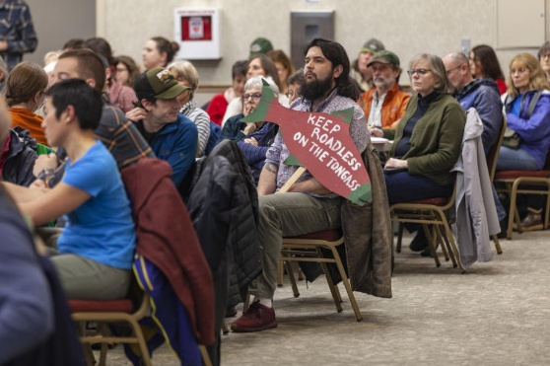
  - Audubon (March 8, 2019, Washington D.C.): Likely Rollback of Roadless Rule threatens remaining old growth in Alaska’s Tongass
  - KTOO (Nov. 4, 2019, Juneau): Forest Service kicks off Roadless Rule discussion in Juneau
  - Juneau Empire (Nov. 4, 2019, Juneau): Empire Live: Alaska Roadless Rule public hearing
The Forest Service began convening resources and personnel to support the agreement. From August to October 2018, the Alaska Region started its scoping efforts in preparation for the Environmental Impact Statement (EIS) process.
That process involved extensive strategic communication, public engagement, environmental analysis, and intergovernmental collaboration. From late 2018 through most of 2019, Forest Service staff hosted public meetings and tribal consultations and disseminated strategic messaging to support the ongoing activities.
In July 2019, the agency released a draft environmental impact statement and proposed the Alaska Roadless Rule. A 60-day public comment period followed, featuring two dozen public meetings to solicit feedback on six alternatives, ranging from full exemption to maintaining existing protections.
The communication effort included talking points, handouts, and face-to-face conversations for public meetings and participation. The agency hosted these informational gatherings across Southeast Alaska, Anchorage, and Washington D.C. to seek input on the proposed rule.
The agency received about 45,000 comments reflecting widespread public interest and engagement in the rulemaking process. The use of a variety of messaging products resulted in numerous examples of media coverage.
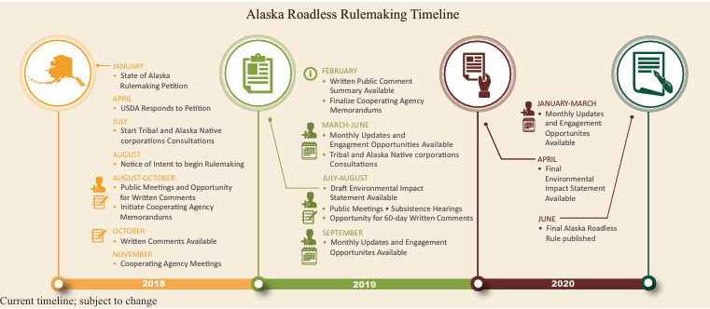

Communication:
- Forest Service seeks comments, announces public meetings on Alaska Roadless Rule (Aug. 30, 2018, Juneau)
- Alaska Roadless Rule Newsletter (March/April 2019, Juneau)
Media Coverage:
- AXIOS (Oct. 15, 2019, Virginia): USDA Forest Service plans to expand logging in Tongass National Forest
- Murkowski News Release: Delegation Welcomes Draft of Tongass-specific Roadless Rule (Oct. 15, 2019, Washington D.C.)
- Alaska Public Media (Oct. 15, 2019, Alaska): Forest Service recommends lifting Roadless Rule for the Tongass
- Daily Sitka Sentinel (Oct. 16, 2019, Sitka, Alaska): Alaska Roadless Rule put out for comment
- Juneau Empire (Oct. 31, 2019): Southeast tribes unite to oppose lifting Roadless Rule
- Daily Sitka Sentinel (Nov. 1, 2019, Sitka, Alaska): Forest Service sets meeting dates for SE
- Daily Sitka Sentinel (Nov. 1, 2019, Sitka, Alaska): Sitkans step up Roadless Rule advocacy
- Juneau Empire (Nov. 22, 2019, Juneau): Opinion: Eliminating Tongass Roadless Rule would benefit Southeast Alaska
- Daily Sitka Sentinel (Nov. 28, 2019, Sitka, Alaska): City goes on record: Keep Roadless Rule
- Daily Sitka Sentinel (Dec. 17, 2019, Sitka, Alaska): Comments closing on Roadless Rule
- Daily Sitka Sentinel (Feb. 15, 2020, Sitka, Alaska): Message on Tongass Mixed? Sitkans ask.
- Daily Sitka Sentinel (May 7, 2020, Sitka, Alaska): USFS commenters favor Roadless Rule
On Oct. 29, 2020, the agency published the final environmental impact statement and the final rule, which exempted the Tongass National Forest from the 2001 Roadless Rule. Communication:
- USDA releases Final Environmental Impact Statement for the Alaska Roadless Rule. (Sept. 24, 2020, Washington D.C.)
- USDA Exempts Tongass National Forest from the 2001 Roadless Rule (Oct. 28, 2020, Washington D.C.)
Media Coverage:
- Juneau Empire (Aug. 24, 2020, Juneau): Opinion: Removing the Roadless Rule would hurt Alaska
- Alaska Public Media (Sept. 25, 2020, Juneau): Forest Service forging ahead with full Roadless Rule exemption for Tongass
- KTUU (Sept. 25, 2020, Alaska): Forest Service advances plan to open 9.2 million acres of Tongass to development
- Republican News (Sept. 25, 2020, Washington D.C.) Delegation welcomes next steps on rulemaking to help Southeast Alaska build a more sustainable economy
- Daily Sitka Sentinel (Sept. 26, 2020, Sitka, Alaska): Plan to end Tongass protection announced
- Audubon Alaska (Oct. 28, 2020, Juneau): Forest Service remove Roadless Protections for Tongass National Forest
- KTOO (Oct. 28, 2020, Juneau): Trump administration will eliminate roadless protections for Alaska’s Tongass forest
- KTUU (Oct. 28, 2020, Alaska): Trump administration to open Tongass National Forest to logging
- Daily Sitka Sentinel (Oct. 29, 2020, Sitka, Alaska): Tongass exempted from Roadless Rule
In June 2021, the Biden administration revealed its intent to "repeal or replace" Trump's removal of the roadless designation. The administration planned to formally publish its intent to revise the Trump-era rule by August 2021, with details of the plan finalized in the following two years.
In November 2021, the USDA and the Forest Service officially published a rule to restore roadless protection in the Tongass National Forest. The rule took effect in January 2023, restoring the 2001 roadless rule and its protections to the Tongass.
Communication:
- Biden-Harris Administration finalizes protections for Tongass National Forest (Jan. 25, 2023, Juneau)
Media Coverage:
- Juneau Empire (June 11, 2021, Juneau): Roadless Rule announcement draws mixed reaction from Alaskans
- Juneau Empire (July 15, 2021, Juneau): Conservation or Constraint? Roadless Rule reversal divides Alaskans
- Daily Sitka Sentinel (July 16, 2021, Sitka, Alaska): Biden takes action to protect Tongass
- Daily Sitka Sentinel (July 16, 2021, Sitka, Alaska): Tongass announcement brings mixed reaction
- Daily Sitka Sentinel (Nov. 23, 2021, Sitka, Alaska): Reactions are mixed to Roadless Change
- SBA (Dec. 6, 2021, Washington D.C.): Forest Service requests comments on proposal to repeal 2020 Final Alaska Roadless Rule
- WA Wild Blog (Dec. 16, 2021, Washington State): Positive media attention grows in support of National Forest Roadless Protections
- Taxpayers for Common Sense (Jan. 25, 2023, Washington, D.C. ): Administration to restore Roadless Rule Protections in Tongass
- KTUU (Jan. 25, 2023, Alaska): USDA reinstates road work, logging restrictions to Tongass National Forest
- State of Alaska (Jan. 25, 2023, Alaska): Forest Service restores restrictions in Tongass, blocking economic development in Southeast
- AP (Jan. 25, 2023, Juneau): US reinstates road, logging restriction on Alaska Forest
- Daily Sitka Sentinel (Jan. 26, 2023): Tongass decision wins local, national praise

Strategic Impact:

Strategic communications were critical in guiding the public, stakeholders, and decision-makers through the complex and politically charged Alaska Roadless Rule process. From its launch in 2018 through the final rule in 2020—and ultimately, the 2023 restoration—communications efforts were central to ensuring transparency, access to information, and broad public engagement.

Faced with high national attention and significant stakeholder division, the communication approach prioritized clarity, legal precision, and inclusiveness. Messaging products were crafted to reflect evolving public concerns, legal milestones, and scientific findings. News releases, newsletters, FAQs, public meeting materials, and media coordination were tailored to multiple audiences, including Tribal governments, local communities, state partners, and national advocacy groups.

This deliberate and sustained strategy ensured that each phase of the rulemaking process—from initial scoping to environmental review, draft alternatives, public comment periods, and final decisions—was accompanied by timely, clear, and accessible information. Strategic use of plain language helped demystify policy terms and environmental regulations, while visual and interactive materials improved public understanding of proposed alternatives.

The result was exceptional public engagement and widespread media coverage. Tens of thousands of public comments were submitted—many informed directly by communications materials and outreach events. .

The consistency of messaging across platforms helped the public follow the evolving narrative—from the initial exemption proposal under the Trump administration to the reinstatement of protections under the Biden administration. Ultimately, the communications strategy supported a transparent, participatory rulemaking process, strengthened institutional credibility, and contributed to lasting public understanding of the Tongass National Forest’s ecological and cultural significance.

Southeast Alaska Sustainability Strategy (2021 - 2023)
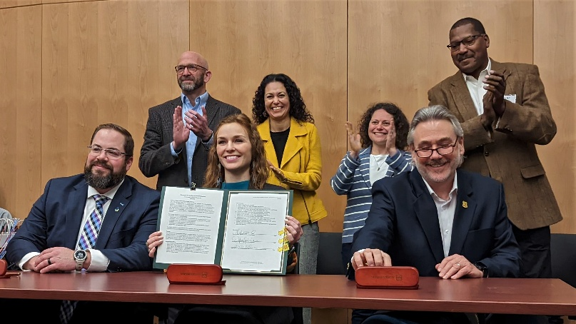

Overview:
The Southeast Alaska Sustainability Strategy (SASS), launched by the USDA Forest Service Alaska Region in summer 2021, represented a significant shift in managing the Tongass National Forest. This initiative emphasized ecological conservation, Indigenous stewardship, and community-driven economic development. The strategy ensured the long-term health and prosperity of the region's communities and natural resources through collaborative efforts and targeted investments.
Strategic communications were foundational to the success and visibility of the Southeast Alaska Sustainability Strategy (SASS), a transformative initiative launched in 2021 to shift the Forest Service’s approach toward community resilience, Indigenous stewardship, and sustainable development.
As the communication lead on the small operational team, I wrote the communications plan, coordinated all messaging, and served as the key point of contact for internal and external audiences. I orchestrated a live news conference for the initiative’s public launch and a follow-up Zoom media call with the USDA Secretary and Tribal leaders to announce significant investments, ensuring message clarity and reach.
I wrote the news releases, fielded media inquiries, identified and prepped spokespeople, and led the development of communication products and engagement platforms. This strategic effort translated complex policy into meaningful narratives that resonated with stakeholders, communities, and national media.
Our earned media efforts spanned from the Juneau Empire to E&E News. They amplified the impact of federal investments, which grew from $1.3 million in 2022 to $6.9 million in 2023, creating more than 100 jobs across Southeast Alaska.
By centering transparency, cultural respect, and results-driven storytelling, our communications helped build trust, support Tribal partnership, and highlight the power of co-management in the Tongass National Forest. Below is a timeline with links to published media products and media coverage:
On July 15, 2021, USDA committed $25 million to support a diverse economy, enhance community resilience, and conserve natural resources in Southeast Alaska. This included ending large-scale old-growth timber sales and focusing on forest restoration, recreation, and resilience.
Communication:
- USDA announces Southeast Alaska Sustainability Strategy, initiates action to work with Tribes, partners, and communities (July 15, 2021, Juneau)
Media Coverage:
- Audubon Alaska (July 15, 2021, Alaska): Biden Administration to restore protections for Alaska’s Tongass National Forest – USDA announces new strategy to protect old-growth trees – important to local communities, birds, and the planet.
- Alaska Business (July 16, 2021, Alaska): USDA announced Southeast Alaska Sustainability Strategy
- Sealaska (July 21, 2021, Juneau): Welcomes USDA funding for local priorities in, around the Tongass
- Juneau Empire (Sept. 23, 2021, Juneau): US Forest Service seeks public comment for regional investment ideas
On March 31, 2022, USDA announced $9 million in investments for 25 projects under SASS, focusing on tribal and Indigenous interests, community capacity, infrastructure, and natural resources. The first year focused on planning and initiating projects. About $1.3 million was invested in 17 projects, creating 22 annualized jobs. The total economic impact was estimated at $1.9 million.
In 2023, SASS investments reached approximately $6.9 million, more than tripling the economic impact from the previous year. This funding supported 47 projects, created 114 jobs, and paid $2.9 million in wages to Southeast Alaska residents. The USDA's multi-year investment plan for SASS includes $25 million in spending, with 59 projects selected for funding and 32 organizations receiving support.
Communication:
- USDA announces $9 million in investments for SASS’s $25 million commitment (March 31, 2022, Juneau)
- SASS Forest Management (April 2022, Juneau)
- Alaska Region wins department and agency awards for listening first (March 16, 2023, Inside the Forest Service)
- Rural Alaska sees economic benefits from the first year of SASS (Sept. 12, 2023, Alaska)
- Southeast Alaska Sustainability Strategy looks at 2022 economic impact (Sept. 20, 2023, Inside the Forest Service)
Media Coverage:
  - Juneau Empire (March 31, 2022, Juneau): USDA announces $9M investment in 25 Southeast programs
  - KTOO (April 1, 2022, Juneau): USDA announces $8.7M in grants for sustainability projects in Southeast Alaska
  - Daily Sitka Sentinel (April 2, 2022, Sitka, Alaska): 4 Sitka projects on list for USDA funds
  - Juneau Empire (Sept. 6, 2022, Juneau): $12.4M awarded for Southeast natural resource sustainability projects
  - Daily Sitka Sentinel (Sept. 7, 2022, Sitka, Alaska): Feds give citizens power over Tongass
  - Alaska Beacon (Sept. 7, 2022, Alaska): Final projects selected in $25 million program for sustainable development in Southeast Alaska
  - Southeast Conference (2022, Juneau): Economic Impact of the USDA SASS investment spending, 2022
  - Southeast Conference (2023, Juneau): Economic Impact of the USDA SASS investment spending, 2023
  - Sitka Sentinel (May 18, 2023, Sitka, Alaska): Forest Service to hold two listening sessions
  - Sitka Sentinel (May 19, 2023, Sitka, Alaska): Forest Service sessions seek advice on Tongass
By 2024, SASS had funded 70 community-based projects through 32 separate entities. These initiatives focused on sustainable economic development, cultural preservation, and environmental restoration. On July 30, 2024, USDA reported that SASS investments tripled the economic impact in its second reporting year, highlighting significant job creation and local economic stimulation.
Communication:
- Collaborative forests and stream restorations benefit Alaskan communities. (Feb. 13, 2024, Inside the Forest Service)
- Southeast Alaska Sustainability Strategy reports triple the economic impact in the 2nd reporting year. (July 30, 2024, Juneau)
- Alaska sustainability strategy boosts food systems (Aug. 20, 2024, Inside the Forest Service)
Media Coverage:
- Sitka Conservation Society (2021-2024, Sitka, Alaska): Sustainability Strategy Investments
- Southeast Conference (2022-2024, Juneau): SASS Fall 2022- Summer 2024
- Juneau Empire (July 31, 2024, Juneau): Woven Peoples and Place: Upper Lynn Canal food systems boosted by regional sustainability initiatives
- E&E News (Aug. 1, 2024, Washington D.C.): Millions spent to offset Alaska Roadless restrictions

Strategic Impact:

Strategic communications were essential to the successful rollout and public reception of the Southeast Alaska Sustainability Strategy (SASS), which redefined how the Forest Service engages with communities, Tribes, and stakeholders in the Tongass National Forest.

From the initial announcement in July 2021 to economic impact reporting in 2024, the communication strategy focused on transparency, collaboration, and storytelling, elevating local voices and conveying the tangible benefits of investment and conservation.

Targeted news releases, earned media coverage, and consistent internal messaging turned a complex policy shift into an inspiring, community-centered narrative. Through active listening sessions, culturally grounded engagement, and accessible messaging, strategic communication helped frame SASS as a funding initiative and a values-based commitment to Indigenous partnership, ecological resilience, and sustainable development.

As a result, the program garnered widespread public interest, earned praise for its communication practices, and maintained staunch support across regional and national platforms. No quote was more profound than President Richard Chalyee Éesh Peterson of the Central Council of the Tlingit and Haida Indian Tribes of Alaska: “Tlingit & Haida welcomes this profound shift that acknowledges and respects Indigenous knowledge and stewardship. I want to thank the U.S. Department of Agriculture and our regional partners for their leadership. The traditional homelands of Southeast Alaska are not just resources; they are the foundation of Tlingit and Haida identity and our collective responsibility to future generations. This effort is a model of co-management and ensures the land remains a source of life and culture for everyone. There is still much to do, and Tlingit & Haida is committed to the power of this partnership to preserve the ecological and cultural integrity of our shared lands.”

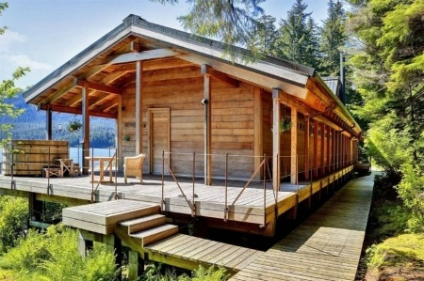
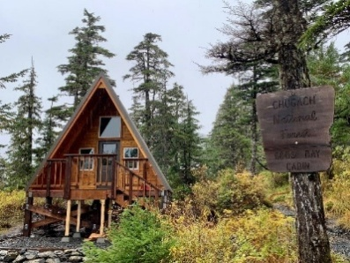
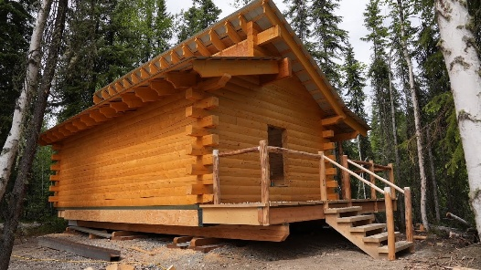
Alaska Cabins Project (2022 - 2025)

Overview:
The Alaska Cabins Project is a collaborative initiative between the USDA Forest Service and the National Forest Foundation. It aims to expand and enhance public-use cabins across Alaska's Tongass and Chugach National Forests. This effort seeks to improve recreational access, promote inclusivity, and support local economies.
The project called for the construction of 25 new cabins and the renovation of existing ones by 2027. It received $14.4 million in funding from the Bipartisan Infrastructure Law (BIL), supplemented by $3.7 million in matching funds raised by the Foundation.
As the communications lead on the Alaska Cabins Project implementation team, I played a pivotal role in orchestrating a unified regional messaging strategy across the Tongass and Chugach National Forests. I authored the comprehensive communications plan, developed key messaging, and produced a suite of communication products tailored for various platforms, including web content and social media.
In addition to crafting news releases and handling media inquiries, I coordinated with forest-level public affairs officers to identify and prepare spokespeople for media interviews, ensuring consistent and effective communication throughout the project's rollout. Below is a timeline with links to published media products and media coverage.
In November 2021, the Bipartisan Infrastructure Law, or BIL, was signed into law, allocating millions of dollars to the Alaska Region to construct and renovate public-use cabins across Alaska’s National Forests.
The Alaska Cabins Project was launched in 2022, along with additional support from the National Forest Foundation. Public engagement began in September 2022, inviting Alaskans to provide input on proposed cabin locations and features.
An interactive, online Story Map with more than 50 proposed sites was released for comment, emphasizing the agency’s commitment to community involvement in recreational planning. This engagement resulted in more than 1,000 public comments, highlighting the community's interest in accessible and family-friendly cabin locations.
Communication:
  - Alaska Region to launch public engagement for Bipartisan Infrastructure Law-funded cabins (Sept. 23, 2022, Alaska)
  - Alaska’s National Forests seek feedback on cabins (Oct. 6, 2022, Alaska)
  - Last day to comment on cabin proposals in Alaska’s National Forests (Oct. 31, 2022, Alaska)
Media Coverage:
  - Anchorage Daily News (Sept. 24, 2022): The Forest Service has millions of dollars for new public use cabins in the Chugach and Tongass. It wants your advice on where to build them.
  - KTOO (Sept. 26, 2022, Juneau): Forest Service to build new cabins in the Tongass and Chugach
  - Juneau Empire (Sept. 27, 2022, Juneau): Where to put a dozen new cabins in Southeast Alaska?
  - Alaska Beacon (Oct. 6, 2022, Alaska): The Forest Service is getting millions for cabins in Alaska, but where should they go?
  - Juneau Empire (Oct. 7, 2022, Juneau): Cabin fever fueled by Forest Service funds
  - Alaska Beacon (Oct. 7, 2022, Alaska): Forest Service seeks advice on sites for cabin projects
  - Anchorage Daily News (Oct. 9, 2022, Anchorage): The Forest Service has released a list of where it could build new public-use cabins in Alaska. Now it is your turn to weigh in
  - KTOO (Oct. 18, 2022, Juneau): Juneau slated to get new cabins thanks to federal funding
By 2023, the first seven cabin sites were announced; their selections were based on public feedback and planning readiness. On the Tongass, three cabin sites were chosen, including the Mendenhall Campground (Juneau), Signal Creek Campground at Ward Lake (Ketchikan), and El Capitan Interpretive Site (Prince of Wales Island). Meanwhile, on the Chugach, another three were identified, including the Trail River Campground (Moose Pass), the Porcupine Campground (Hope), and Meridian Lake (Seward); an additional cabin at Anan Bay near Wrangell was included to replace one destroyed by a fallen tree.
Communication:
  - National Forest Foundation (2022-23, Alaska): Alaska Cabins Project
  - Alaska Cabin Project welcomes the National Forest Foundation as an operational partner (Feb. 9, 2023, Alaska)
  - Locations confirmed for the first seven of 25 cabins to be built on Alaska’s National Forests (Aug. 1, 2023, Alaska)
Media Coverage:
  - KDLL (June 21, 2023, Anchorage): Forest Service plans five new Chugach Cabins
  - Juneau Empire (Aug. 1, 2023, Juneau): New Forest Service cabin coming to Mendenhall Campground
  - KTOO (Aug. 11, 2023, Juneau): Sites announced for 7 new Tongass and Chugach recreation cabins
From 2024 to 2025, construction progresses for several cabins, including the Porcupine Cabin near Hope. Reservations for this cabin opened in January 2025. The project called for building 25 new cabins by 2027, with at least one cabin in each of the 11 ranger districts across the Tongass and Chugach National Forests. Site selection for the remaining 18 cabins was ongoing, guided by public input and site feasibility assessments.
Communication:
  - Rebuilding Martin Lake Cabin and the public-use cabins project (Sept. 26, 2024, Cordova, Alaska)
Media Coverage:
  - Alaska Public Media (Sept. 18, 2024, Alaska): Alaska Cabins Project will lead to 25 new public use cabins in the state
  - Modern Campground (Sept. 19, 2024, Ohio): Alaska Cabins Project set to expand accessible public-use cabins in Chugach, Tongass Forests

Strategic Impact:
Strategic communications were central to the success of the Alaska Cabins Project, ensuring consistent messaging, widespread public awareness, and strong community support across both the Tongass and Chugach National Forests. Because the project spanned two distinct forest units, communications efforts focused on unifying the message across regions while tailoring content to resonate with diverse local communities.
A clear and coordinated communications plan helped convey the project's goals—enhancing public access, recreation equity, and sustainable use of national forest lands—through user-friendly web content, social media posts, news releases, and interviews. Strategic outreach also included identifying accessible spokespeople and responding promptly to public and media inquiries, reinforcing transparency and trust.
The communication effort helped frame the cabins as infrastructure improvements and tangible symbols of federal reinvestment in rural Alaska. This approach fostered strong earned media coverage, boosted community excitement, and built momentum for future construction phases, turning a policy investment into a widely celebrated public benefit.

Alaska’s National Forests Theme Project (2022 - 2025)

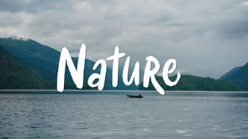

Click the image above to watch the Tongass National Forest Theme video

Overview:
The USDA Forest Service Alaska Region launched its new theme, "Alaska's National Forests—where Nature, People, and Tradition Come Together," on Feb. 1, 2023. This initiative highlighted the unique cultural, ecological, and recreational values of the Tongass and Chugach National Forests. Years in the making, the brand-new Alaska Region messaging campaign shines the spotlight on the stunning landscapes of the Alaska Region's Tongass and Chugach national forests, the multiuse of resources on both, and the tribal traditions that have been around for millennia in and around these remarkable public lands.
The Alaska Region Theme Project was a signature effort in which my leadership, vision, and communication expertise guided every phase, from concept to launch. This initiative was more than branding; it was a unifying message designed to reflect the identity, purpose, and heart of the Forest Service in Alaska.
I led the development process, shaping the theme, crafting the messaging, managing creative production, and securing regional and national buy-in. Every communication product—from the theme video and news release to internal rollout materials and public-facing content—carried my strategic imprint. I coordinated with leadership, staff, and partners to ensure the theme resonated across diverse audiences, internally and externally.
The result was a powerful narrative that helped unify the region’s work under a cohesive identity rooted in people, place, and tradition, strengthening morale, sharpening public messaging, and giving the Alaska Region a voice that truly reflected its values.
The region started exploring its theme in 2019 and 2020. After gathering input from employees, forest users, partners, and exploring the agency’s core values, the Alaska Region leadership team selected the new campaign in April 2021.
The project included developing three professionally produced five-minute videos, short social media vignettes, and complementary posters and fliers. The multimedia products featured extraordinary visuals and heartfelt interviews with various Alaska Region leaders and employees, forest visitors, partners, outfitters and guides, and tribal leaders.
A contracted video vendor filmed in both forests in summer 2022. The region also obtained raw video from other sources, including the Central Council of Tlingit and Haida Indian Tribes of Alaska, the Kenaitze Indian Tribe, Hecla Greens Creek Mine, and Points North Heli Adventures. The region contacted partners and community entities to help share the remarkable message. The videos and other products were amplified in many local and regional locations, centers, offices, online, and uploaded to specific websites.
The short films were shared with Tribal nations, partners, community organizations, visiting cruise ships, ferries, local movie theatres, and welcome centers in or near the two forests. They were also available to be shown at workshops, seminars, presentations, and visitor or employee orientations. The theme serves as a testament to Alaska's national forests' rich heritage and natural beauty, emphasizing the interconnectedness of nature, people, and tradition.
Communication:
  - New messaging THEME shares the many voices heard on Alaska’s National Forests (Jan. 18, 2023, Juneau)
  - Alaska Region launches a new theme Feb. 1 through videos, visuals (Jan. 24, 2023, Juneau)
  - Alaska Region theme video inspires national forest visitors (May 9, 2023, Juneau)
  - Alaska – where nature, people, and tradition come together (Aug. 19, 2024, Inside the Forst Service Features)
Multimedia or Media Coverage:
  - Alaska’s National Forest Theme Video - Regional (2023, Juneau): https://vimeo.com/showcase/9309003/video/787741044
  - Alaska’s National Forest Theme Video – Chugach (2023, Anchorage): https://vimeo.com/showcase/9309003/video/787711374
  - Alaska’s National Forest Theme Video – Tongass (2023, Southeast Alaska): https://vimeo.com/showcase/9309003/video/787764793

Strategic Impact:
Strategic communication was not just a tool; it was the driving force behind the lasting success of the Alaska Region Theme Project. Through intentional messaging, unified visuals, and values-based storytelling, the theme, centered on “Nature, People, and Tradition,” became more than a campaign; it became a cultural touchstone for the region.
The strategic approach ensured the theme was embedded across every platform, from social media and videos to internal briefings, leadership remarks, and public affairs products. This consistency transformed how the Alaska Region communicates, providing a clear, authentic identity that audiences recognize and staff embrace.
Today, the theme shapes every messaging opportunity, serving as a framework that guides tone, content, and connection. It elevated the region’s voice, strengthened trust and recognition, and created a cohesive brand narrative that unites all communications, proving the power of strategic communication to build something enduring and meaningful.

Conclusion
A Legacy of Strategic Communication in Alaska (2018–2025)
This portfolio displays a body of strategic communication work that spans my entire tenure with the USDA Forest Service Alaska Region, from 2018 to 2025. It highlights my leadership and authorship across four major, high-impact initiatives: the Alaska Roadless Rule, the Southeast Alaska Sustainability Strategy (SASS), the Alaska Cabins Project, and the Alaska Region Theme Project.
Collectively, these efforts represent the whole arc of public engagement and policy storytelling, ranging from regulatory processes and investment rollouts to cultural identity and place-based branding.
Across these four projects, I led a six-person team of communication experts, and with my guidance, developed and distributed dozens of communication products, including comprehensive communication plans, news releases, internal briefings, videos, websites, media kits, and social media content. These products were instrumental in securing broad public awareness, participation, and trust. The work generated dozens of documented media stories from local media outlets such as KTOO, Alaska Public Media, the Juneau Empire, and the Daily Sitka Sentinel, and national outlets such as E&E News.
These projects were not isolated wins—they were building blocks of a larger, coordinated vision for how the Forest Service in Alaska communicates. Whether navigating national controversy, launching a historic sustainability initiative, expanding recreation access, or building an enduring regional theme, the throughline was always the same: strategic communication that is audience-centered, engaging, and rooted in public service. This portfolio reflects my commitment to those principles and demonstrates the long-term value of communications that inform, inspire, and endure.

###

